06/13/12

K40 number is healthy, and the machine is fully functional.

Na-K40 number has been tweaked rather carefully. We now have slightly different K40 loading parameters, and the bias field ramps during decompression. 🡺 All in all, we have a decent starting point for doing polaron rf.

Today’s bare K40 spectra at 132.1G (PODT: 0.15, CODT: 0.12V):



* Slightly wider than before, but it doesn’t stop us yet.

From now on, we should make use of blackman pulses exclusively. Using Agi Gaussian to generate the waveform for agi agilent2.

Rabi flopping with square pulse:



Here’s a preliminary K40 rf spec with Na (near pure) BEC using a 400us blackman pulse (nearly a pi-pulse):



Although it comes out broken, the left axis is the m5half barencount. The m1half signal is so weak, that I’m not sure if it’s a good idea to look at transfer ratio. Perhaps, we can try to re-analyze the data with a better normalization box and smaller region of interest.

FYI, here’s the averaged ratio vs frequency:



…and, here’s the reference bare K40 spectrum with the same pulse characteristics. Here, I show the transfer ratio vs rf frequency:



I also tried compressing the ODT a bit. (CODT: 0.4V, PODT: 0.17V) I didn’t want to compress too much, since doing so creates thermal Na atoms.

ratio:



bare m5half ncount:



Being ambitious, I tried 2kHz interval pulses for a wider range with NO ODT compression (with Na BEC). It didn’t seem like I would see any interesting feature, so I stopped inbetween. We need a fatter condensate…



06/13/12

Yesterday, the K40 atom number was too low to have any reliable rf measurement. Also, the top imaging quality deteriorated (partly due to dust gathering, but mostly due to us touching the K40 z-imaging beam alignment a while ago…), generating more background noise.

As an attempt to increase atom numbers, we tried re-aligning the ODT beams with completely new beam balance. We tried dumping most of the ODT power to one of the two beams, but in the end we balanced the two beams and aligned. The Na BEC in ODT went down a little bit after this procedure.

Things to do today/tomorrow:

1. Do a systematic study of where we lose our atoms, starting from magtrap.
2. Measure the ODT beam waists, and try changing the beam waists.
3. Must improve K40 z-imaging quality.

Okay, for now, I’ll do a systematic check of atom numbers during a typical sequence. Here’s the atom number evolution: (note: I load both K40 and Na full 🡺 8s K40 loading, 6s Na loading)

|  |  |  |
| --- | --- | --- |
| TOF = 3ms for K40, 10ms for Na | Na | K40 |
| After evap2 | >8M | 200K |
| After ODT up | 4.5M | 80K |
| After ODT up (after tweaking bias fields during decomp) | 4.5M | 150K |
| After Na spinflip, imaging the remaining atoms in (2,2) | 1.2M (!!!!!) | 150K |
| After Na spinflip, imaging the remaining atoms in (2,2) (after tweaking Na spinflip) | 150K (!!!!!) | 150K |
| After Na blaster, imaging the (1,1) atoms using repump-probe | 3~4M | 100K~150K |
|  |  |  |

Small things that I noticed:

* Bad bias field was switched on during Na spinflip
* Magtrap center position heavily affects how many atoms get transferred into ODT
* Why does switching on the Na repumper light for 30us affect the observed atom number so much? Okay. I figured it out. Turns out, our repump-probe imaging will not work with the double kinetic mode. When we run the Andor camera on fast kinetic, after taking the first image the camera doesn’t “close” its shutter before recording the following image on the second half of the ccd. So half of the ccd is fully exposed to the repumping light.  
  🡺 fudge factor between Na no repump imaging and yes repump imaging = 4.5

After fixing these problems, we’re in a much better shape in terms of atom number compared to before:

Na BEC:

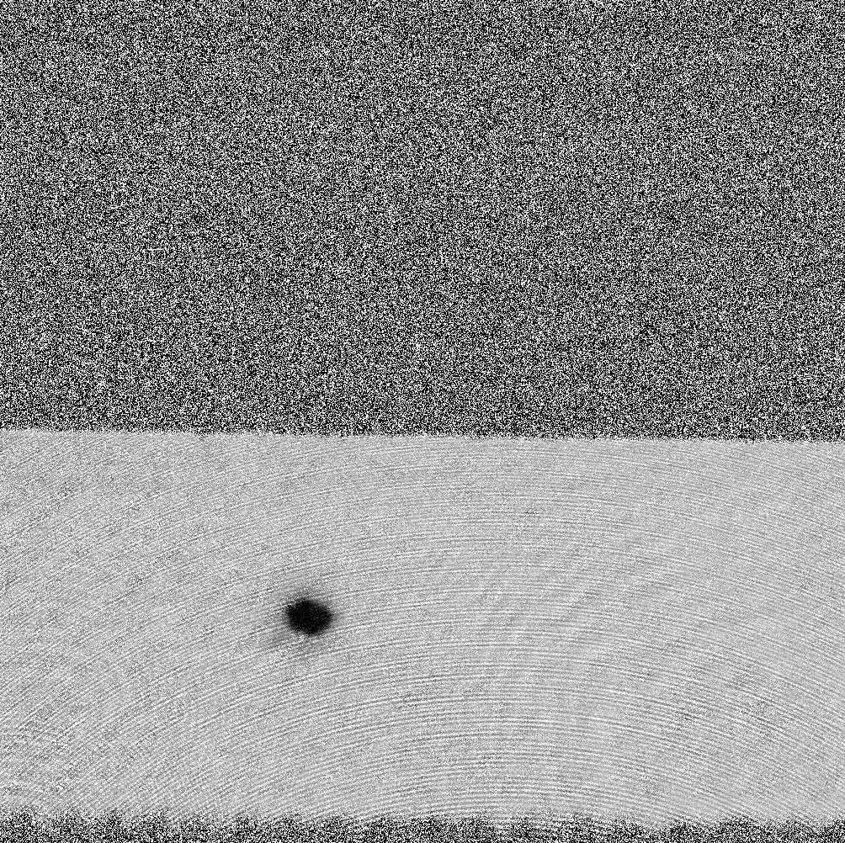

K40 high field imaging in m1half:

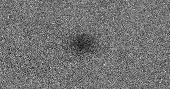

06/14/12

Today, we’ll take rf-spectra with the new atom numbers!

Before that, here’s the standard Na F2 BEC in ODT standard:

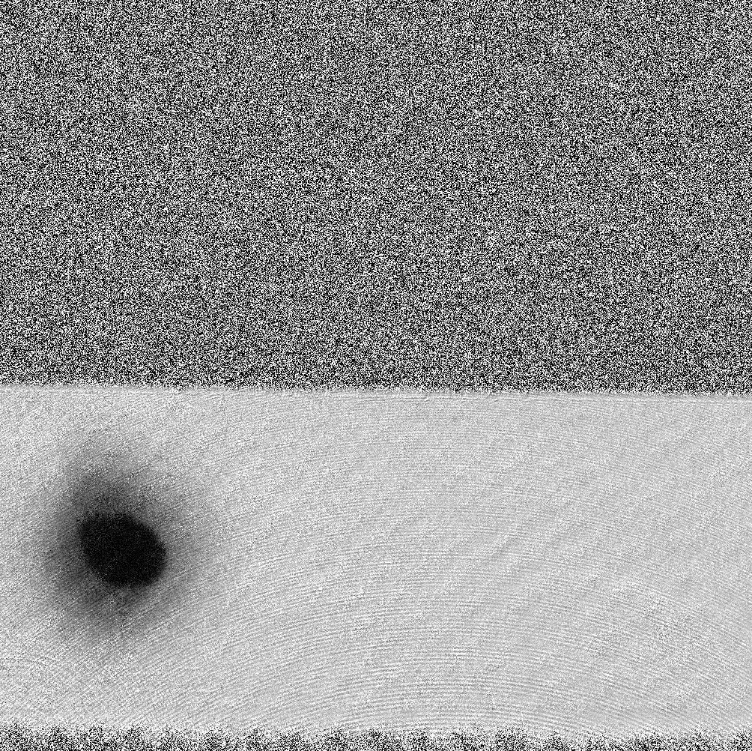

06/17/2012

We spent some time investigating the (in-)stability of the machine, and we found some good knobs:

* The window used to split of light along the PODT path to lock the ODT created interference on the photodiode, due to the two reflections coming from two faces of the window  
  🡺 This problem is fixed by using a nice IR coated wedge from CVI to clearly separate out the two reflections, and use only one of them to lock the ODT  
  🡺 We noticed that switching on the CODT slightly perturbs the PODT lock. It doesn’t seem to affect the stability of the machine, but a beam block has been purchased to block of any glare coming from the CODT locking path.
* The flipper mount for high field imaging is making a funny noise when it flips in/out. Sebastian mentioned that we have one extra in stock. We should locate this, and keep it at a safe place.
* More importantly, the battery for the flipper mount controller was dead. We believe this is the reason why we suffered from K40 atom number instability on Thursday (and Friday). 9V power supplies have been bought to replace all the batteries.

After fixing these problems (esp. the ODT problem), the Na BEC alone is extremely stable – if you don’t pay attention, it’s hard to tell whether the image updated or not! Awesome. The shape of the condensate doesn’t change like it used to.

Lab temperature is also very stable. Cranking up the fan speed definitely helped a lot! We have much stronger air circulation, which makes the PID loop much responsive. Now, it takes about 1 hr for the lab temperature to stabilize after switching on the machine, and also the night-day swing is only about 1degree Celsius. Great improvement!

K40 atom number is somehow low today. We’ve been having some issues with K40 stability/atom number recently. I tried tweaking some knobs that I could think of, but nothing seemed to help. It would be good if we spend some time conquering the K40 stability/number problems. Na alone seems very stable, so once K40 in under control, we will be in better shape to take well controlled data. Some things I can think of are:

* Tweak fiber coupling for pumping.
* Get better thermal insulation for the K40 laser system (maybe even similar to our Na table).
* Check if polarizations for PM fibers are set properly.

Also, we put some photodiodes on the experimental table to monitor K40 light powers (esp. MOT and pumping). We need another 4-channel scope to constantly monitor these photodiodes. I’m getting a quote for one on Monday. If the price isn’t too crazy, I’ll immediately put through a PO.

Here’s an image of the condensate after tweaking the ODT: